**CHAPTER 1**

**THE PROBLEM AND ITS BACKGROUND**

**1.1 Introduction**

Language is an important part of every people’s lives. It is through language we communicate our thoughts and exchange ideas. Language plays an important role in our society it is the medium of knowledge and intelligence. As much as it is important to people, it is also important to computers. Computer programming language (PL) is used to communicate human intelligence to computers. It is instructing how should a computer function and do certain jobs. One of the most significant part of a PL is the syntax and it used to construct and formulate a logic.

Logic formulation and syntax is the key part of a PL and many students learning computer programming have trouble understanding the concepts underlying these key parts. This leads to the inability to write and produce a program and also will slow the learner's capability in learning new PLs.

This issue is due to the lack of focus in logic formulation. A lot of mentors that teaches programming focuses on the PLs functions and statements but does not emphasize logic behind programming especially to new students. Some student also, disregards the creation of flow charts and pseudo codes and start on coding without formulating the logic. This complicates as new PLs are presented as it is somewhat forced to students to learn new PLs.

With the aforementioned issues, the proponents proposed “Rewop” an Android Based Programming and Role-Playing Game.

**1.2 Project Objectives**

        The main objective of the project is to develop ”Returning Wrath of Pseudo” an Android based role playing game that will enhance the players capability in formulating logic as base knowledge in learning programming

Specifically:

1. To construct the project's gameplay and plot
2. To design the game using UML designing tools
3. To developed a game on the Unity 3D engine using C#
4. To evaluate the acceptability of the game using the ISO/IEC 25010

**1.3 Project Scope and Limitations**

The project will primarily focus on the development of a single-player role-playing game for learning basic programming. The story is all about a gamer namely – Nexo, One day Nexo decided to play the game. He noticed that the game changed and some unknown NPC's are in the game scene. While connecting with the game to play with his friends, some glitch suddenly happened and in a snap Nexo captured by the game. The player awoke in the game with the other two top players Pseudo and Pheta. Both are also stucked in the game. They were at the village of Eankor and the town’s people were panicking. The village was raided by Minions. The game is divided in to 3 worlds namely; "Overworld", "Underworld", and "Na'rak". This worlds is actually inspired with Super Mario Brothers game. Each world has 3 stages, every stages has 5 quest.The logic formulation for programming will introduce at the end of every stages in which the player will construct a block statements in order to defeat the boss. The player will be battling with a boss by using block programming. The tutorial for logic formulation will appear the the 2nd stage of world 1 “Overworld” in order to defeat the boss at the last stage of world 1. This battles will increment in difficulty as the game progresses. The game will automatically save at the end of each quest. The achievement of the game . . . . .The game will have a reset button at the setting to restart the game.

The game will be running in an Android operating system with a minimum version of 4.1 Jelly Bean. This game will be having 3D graphics and model the game using Blender, and Photoshop CC 2015. There’s no need internet connection to play the game. The development of the game will be covering the whole academic year from July 2017 to February 2018.

**1.4 Project Description and Purpose**

The Returning Wrath of Pseudo is a puzzle & role playing game that helps to teach basic programming. It’s a story of defecting Pseudo who created the bug of the top MMORPG game named “Wrath of Legends”. Unfortunately he can’t defeat Nexo the No.1 player in the game. To make his revenge, he created a bug to capture the top player and become part of the game. Pseudo include all the top player to play the “Returning Wrath of Pseudo”. Unfortunately, the bug included Pseudo in capturing into the game. Now, their quest is to go back to the real world by completing the quest inside the bug.

The following is the modules of the game. The game is a 3D third-person view game. Consist of save points of each world that the player accomplished. Aside for the side quest, there are achievements. A feature of the game is the simulation of block programming to fight the boss in each stage. The game displays per accomplished and achievements. The game’s story begins when Nexo decided to play the game. While playing, he noticed that the game has changed and some unknown NPC's are in the game scene. While connecting with the game to play with his friends, some glitch suddenly happened and in a snap Nexo captured by the game. They were at the village of Eankor and the town’s people were panicking. The village was raided by Minions. After clearing all Minions, a host virus abducted Pseudo and Pheta and Nexo are left alone. He arrived at the market and fought remaining minions there and after clearing the minions. The market was like a ghost town as no people is present. There Nexo founds a dead guy and he acquired the preview. The preview is a device that can see future actions of a generic virus. He then fought the virus. Using the preview he fought the drone virus by countering his attacks using a script. After defeating the virus, Nexo proceeds to the passage way where the fort lies. Nexo arrived at the fort and it was heavily guarded by minions. He attacked the minions and after killing the minions, he entered the fort and found a great door. Inside was a rook virus and a loophole. A loophole is a passageway to another world. Nexo defeated the rook virus using his script and now he must enter to the loophole because his two friends were not seen in the fort. Nexo was transported to the Underworld. There were more vicious minions inside the underworld. He found the host virus that captured his two friends. He fought the virus and acquired some information that his two friends is in the Na'rak the deepest world in WOL. Nexo went to the first passage way and found a drone virus. He fought the virus but as he was fighting the preview glitches and Nexo uses the "If" to counter-attack the glitches functions. He arrived at the second level of the underworld. There, more vicious minions were guiding the hallway and when they see any people they will attack and kill anyone who passes by. Nexo must safely pass this maze-like structure without catching attention of the minions. Nexo continues with the journey. Nexo shocked by seeing the Overlord dead lying on the floor and there’s a bag containing a “loop” function. The castle was heavily guarded by minions. After defeating the boss’ stage, Nexo went to the Na’rak. At the Na’rak, there was a terrible vibe and there were the first Rook Virus which was now more powerful, he defeated it by script battle and after that another Rook virus and he also defeated it through script battle and after that he faced the master virus. This was the main virus which lead to the destruction of the villages and towns of the Overworld. He, with all his strength defeated the master virus and he found Pheta and the key to the brain but Pheta warned Nexo it was cut when the main virus regenerated and now after defeating Pseudo appeared and it was found out that Pseudo is the one controlling all the viruses. A portal opens to the real world and Pheta and Nexo saves Pseudo and entered the portal the game crashes and they were all out of the game and their story ends.

**User**

The purpose for the end users are they can learn while playing and to have knowledge for the basic programming.

**Researcher**

This project willl not only the end users have the benefits, the researchers developed their skills for developing game and developed teamwork skills.

**Future Researcher**

This project will also be benefits for our future researchers that they can be their future reference if their project is similar to ours.

**Chapter 2**

**REVIEW OF RELATED LITERATURE AND STUDIES/SYSTEM**

This chapter contains the review of related literature and related studies that contains relevant and useful information related in conducting and conceptualizing this study.

**2.1 Foreign Literature**

**Game (General Information)**

Video games are electronic, interactive games known for their vibrant colors, sound effects, and complex graphics and video games encourage players to become a part of the game's script that's why they called a unique form of entertainment. Although video games have been available for more than 30 years, today's sophisticated video games require players to pay constant attention to the game. People that play games are engaged deeper physically and emotionally than people watching a movie or TV. [1]

In 1970s, the first mass-marketed video games are played by installing cartridges. The characters face obstacles displayed on the screen as the player manipulates a joystick or controller to control the actions of a character. Video games, can also be played in arcades, computers and on small hand-held screens designed chiefly appeal to children and adolescents. In the United States with children had one or more of the most popular game systems as of 2004, for example, Nintendo GameCube, Sony Playstation2, or Microsoft Xbox. Some form of video game for some children have not been exposed, and access to the games is readily available to children from all walks of life. From the start, video games for home use proved popular. Children are particularly attracted to them for a variety of reasons. The teenagers has easily attracted by fantasy characters and scenario to provide an escape from everyday routine and stresses presented by parents, friends and school. In addition, the games give children a level of control that they do not experience in real life, as the characters on the screen respond to the children's commands. Players will receive rewards if they make the right moves. Most games can be played at a variety of skill levels so that every player can be challenged. The controversy about the popularity of video games has been matched and they have sparked among parents, psychologists and educators. The most prevalent objection results from the violent themes and characters that dominate in most video games. According to a 1989 study by the National Coalition on Television Violence (NCTV) of the 95 most popular home video games, 58 percent were war games and 83 percent featured violent themes. Children's behaviour has changed because of the effects of video games that show situations and characters that are more realistic cause by some improved games. One NCTV study that monitored the playground behaviour of eight to ten-year-old immediately after playing a laser-weapon game found an 80 percent increase in fighting. There is also added concern that repeated exposure to violence desensitizes children to its effects. Other experts and video game manufacturers contend that negative effects have not been proven adequately, and, in fact, playing such games gives players an avenue for the harmless release of stress and aggression.

In the early 1990s, some manufacturers of video games begin to label with warnings about violent or sexually explicit content. In 1994, in response to considerable political pressure and the possibility of a federal rating agency, the industry created its own rating system, overseen by the Entertainment Software Rating Board (ESRB). The suitability ratings for various age groups are assigned based on the games. An "Early Childhood" designation on a game box indicates that the game is suitable for players ages three and older, and there is no violence, sexual content, or profanity. The designation "Everyone" indicates the game is for players ages six and older and may contain minimal violence or crude language. Some "Teen" games may contain violence for ages 13 and up, profanity, and mild sexual themes. A games for mature ages is considered suitable for ages 17 and older and may include more intense violence, profanity, and mature sexual themes. "Adults Only" games are not intended for people under 18 and may include graphic depictions of sex and violence. The ratings system, however, is just a guide, and parents still need to oversee which video games their children buy and play. In the past, the issue of gender bias in video games was another area of considerable debate. Not only were most video games male-oriented sports and combat games, female characters in the games were portrayed as victims to be rescued by the male hero or objects of violence or sexual desire. In the early 2000s, however, an increasing number of games had girl-oriented themes and an increasing number of gender neutral games became available.

In the early 1990s, medical concerns were also raised, the socialization concerns presented by video games, when video games were linked to epileptic seizures experienced by some 50 children. The previous seizures experienced by one third of the children, and there were questions about whether the seizures they experienced were related to playing or watching a video game. Two large studies later reported that the children who experienced video game-related seizures. The children who experienced video game-related seizure (VGRS) reported by two large studies that they were particularly sensitive to light and with flashing lights that merely precipitated games, rather than caused, the seizures. Sitting too close to the screen could exacerbate the effects of the light sensitivity, as could the increasingly complex graphic technology featured in games. Individuals with epilepsy are not thought to be particularly susceptible to VGRS, and no lasting neurological damage had as of 2004 been linked to these seizures. Benefits have also been noted despite of the controversy about the video games: development of hand-eye coordination, increases in concentration, logical thinking skills, and healthy competition among children, as well as socialization skills gained from sharing strategies and the heightened self-esteem resulting from successful performances. Based on the researched found that doctors who had played more video games had better surgical skills.

**Genres**

The most video game genre is a specific category of games related by similar gameplay characteristics. Some bridge different gaming styles and, thus, could appear under more than one category simultaneously and others pioneer new approaches to electronic entertainment. Those often fall outside of any pre-conceived genre. A new gameplay genre comes if such a title becomes popular and others try to duplicate the experience. It is easy to classify particular titles much more narrowly and, thus, create dozens of genres and/or sub-genres. However, this is an attempt to give a broader perspective of types of video games. [2]

This are the examples of game:

**Adventure:**

In 30 years, Adventure games has been the most story-driven computer game. Another of the first video game genres, especially from the computer platforms, was the adventure game. These were initially text-based games like Will Crowther's Collossal Cave and the original Zork games. However, as the power of the gaming systems grew, developers tried to tap into the visual capabilities of each consecutive platform. The Atari VCS offered a game entitled Adventure. Roberta Williams began developing the King's Quest series for Sierra Online in an attempt to add interactive graphics and point-and-click functionality to the more puzzle-oriented traditional text-based adventure. The puzzle-solving has always been a strong following for this type of genre because they are challenging and general lack of violence. This has also made it popular for many non-traditional gaming demographics. In recent years, Lucas Arts and Cyan have been known for their contributions to the adventure genre. Other examples of adventure franchises include Gabriel Knight, Indiana Jones, Maniac Mansion, Monkey Island, Myst, Police Quest, and Syberia. [3]

**Role-Playing Games (RPGs):**

RPGs are a special type of [adventure](https://www.thocp.net/software/games/reference/genres.htm#Adventure) game that usually incorporate three major elements: 1) a specific quest, 2) a process for evolving a character through experience to improve his/her ability to handle deadlier foes, 3) the careful acquisition and management if inventory items for the quest (i.e., weapons, armor, healing items, food, and tools). Having said that, these games still have many variations and appearances.

**Puzzle:**

Traditional puzzles are similar to Puzzle video games. It's not easily to introduce in one's living room that have unique environments. For example, Wetrix enables the player to build up a series of walls that would be able to contain a deluge of water when it falls. Successful completion of a level involves capturing enough water. Other examples include Tetris, Intelligent Qube, Puzzle Bobble, PuyoPuyo, Devil Dice, and Mercury.

**Strategy/Tactics:**

Strategy/tactics games attempt to capture a sense of realism for the game player to experience. However, these titles are often turn-based as opposed to real time and they give the player a greater sense of specific control over a situation. Franchises that fall into this genre include Ogre Tactics, Command and Conquer, Final Fantasy Tactics, and Worms.

**Fighting:**

These titles pit player against player (usually 2 players head-to-head) and involve one triumphing over the other. Many of these games include a single player mode, but the real draw to this genre is the ability to demonstrate one's gaming prowess against a friend. Examples of franchises in this genre include Street Fighter, Soul Calibur, Mortal Kombat, Tekken, Virtua Fighter, Dead or Alive, King of Fighters, and Bloody Roar.

**Hybrids:**

It's important to recognize that many games are not limited to a single genre. Some are the combination of two or more game types. In fact, as gaming evolves, we see lines blurred between genres more frequently than not. Since the introduction of 3D gaming, the action/adventure genre has grown dramatically. It is practically a catch-all category that incorporates 3D games with real time combat and puzzle-solving in a fairly cohesive storyline. Many of these games are also first-person-shooters. Some are 3D platform titles. And most survival horror titles qualify as Action/Adventure games too. Another example of a hybrid is [Myst](https://www.thocp.net/software/games/modern_age.htm" \l "Myst). It is both an adventure game and a puzzle game. However, it is most certainly not an Action/Adventure game.

**Types of Games (2D, 3D and 2.5D)**

3D gaming is interactive computer entertainment that is graphically presented in the [three dimensions](http://whatis.techtarget.com/definition/3-D-three-dimensions-or-three-dimensional) of height, width and depth; the addition of depth to 2D [gaming](http://whatis.techtarget.com/definition/gaming) enabled the exploration of virtual worlds with more realistic representation. [4]

Wire frame models where the first developed of a true 3D games. The 3D models, which had no shading, were made from vertices and lines and could be seen through. Elite was the first of this new generation of video games, in 1984. Flat-shaded 3D polygons with 16 colors arrived with Bethesda's Terminator in 1990. The game’s graphics were visually inferior to competing 2D graphics of the time. Nonetheless, 3D representation pushed the current hardware – [286](http://whatis.techtarget.com/definition/Intel-80286)- and [386](http://whatis.techtarget.com/definition/Intel-80386)-based computers -- and thus were an impressive achievement within their limitations.

In 1992, iD Software released Wolfenstein 3D. Although it is termed 2.5D or pseudo 3D, Wolfenstein launched iD’s reign as the premier graphics engine makers. John Carmack, who later left iD to work on Oculus Rift, was the programmer.

iD Software's first true 3D game is a major breakthrough in 3D gaming came with Quake. Quake featured full-color textured models and particle effects with the help of the sound of Trent Reznor of Nine Inch Nails. While playable without additional hardware, Quake’s performance was significantly enhanced by 3D-accelerated [video cards](http://whatis.techtarget.com/definition/video-adapter) and [daughter boards](http://whatis.techtarget.com/definition/daughterboard-or-daughter-board-daughter-card-or-daughtercard) from S3 Graphics and later by 3dfx’s Voodoo video card, which emerged as the standard for some time.

After the release of Quake, the field of 3D gaming rapidly developed. Games gained faithfulness, and additional features were added with the creation and development of [GPUs](http://searchvirtualdesktop.techtarget.com/definition/GPU-graphics-processing-unit) (graphics processing units). Today, a single-character model may feature tens of hundreds of thousand polygons and scenes in games can have tens of millions. Models are surfaced by color, specular glow and wonderful maps that attract the user, normal or displacement maps, define their colors and reaction to environmental light.

2D video games refer to action happening on a 2D plane and typically are either horizontally-scrolling or vertically-scrolling. What's more, the characters, objects and environments are usually rendered in 2D. [5]

2D or two-dimensional is the concept of everything being on one plane of existence. Two-dimensional plane can only move along the horizontal X-axis and the vertical Y-axis. The Z-axis, defines depth that considered null. A classic example for two dimensional graphics and gameplay is the Super Mario Bros., side-scrolling plat former in which the player has limited for movement left, right, up, and down. [6]

In the early years of video, 2D games were most frequently developed games for various reasons. One reason for this is that the technical limitations of game hardware prevented the ease of creating three-dimensional graphics. During the Super NES era, Nintendo developed a scant few games that made use of what the company deemed the "Super FX Chip." This special chip allowed for the development of games using rudimentary polygon graphics for games such as Star Fox and Stunt Race FX.

The 2.5D animation is 2D animation in a 3D space. Sometimes this involves actually moving 2D-animated objects in a 3D space; sometimes it involves using clever tricks of perspective and shadow to make 2D space look like 3D space, although you're still working on a 2D plane. This creates a certain fluidity and changes in depth that make us think we're looking at 2D paper cut outs moving in a 3D space, almost like paper dolls standing on a table.

The 2.5D effect also extends to objects that don't look like paper cut-outs, but just typical 2D animations - but they appear to move in a 3D space. The 3D space around a 2D object, this can be as simple as a character's head turning, but it moves with that 3D fluidity that makes it seem like a 3D object with flat shading and outlines to give it a 2D look, and further creates the impression of. [7]

**Major roles of Games**

**Advantages and Disadvantages**  
- Cause different problems such as obesity.  
- They can cause inattention   
- Isolation  
- Some are extremely violent and cruel.  
- Transmit inappropriate values ​​.  
- May cause addiction.  
- Parts of the brain responsible for speech, memory, motor control, emotions begin to damage because our society spends too much time playing video games.  
- In countries such as Taiwan, Spain, China, Brazil, Argentina, Russia, France, USA, Canada and South Korea have between 50 to 61.4 % addicted to video games.

**History**

The “platform” refers to the specific combination of electronic components or computer hardware which, in conjunction with software, allows a video game to operate. The term "system" is also commonly used. [8]

Type of platforms: Pc game, console game, arcade game, handheld and many more.

**Memory**

Video games make players visions become more sensitive to slightly different shades of colors. This is called contrast sensitivity, and observed particularly in first person shooter games players.

Video games help children with disorder reads faster and with better accuracy.

**Platforms**

A reality that a lot of people play video games also that video games can have a positive or a negative role in the persons that use it.  
When its play a positive role:  
According to the research of Lisa Bowen an American Psychologist:  
-Playing video games can help children’s to develop problem solving skills and learning skills:  
-Playing video game can help person to feels relax and control stress:  
-Video Games also are good to relief pain:  
-Video Games improve vision:

Video games has a positive and negative sides for people who plays a particular video game because it cause mental disorder or it can give people ability to enhance their imagination.

**Purpose**

The history of video games goes as far back as the early 1950s, when academics began designing simple games, simulations, and artificial intelligence programs as part of their computer science research. The first commercially viable video game was Computer Space in 1971, which laid the foundation for a new entertainment industry in the late 1970s within the United States, Japan, and Europe. Video gaming reached mainstream popularity in the 1970s and 1980s, when arcade video games, gaming consoles and home computer games were introduced to the general public.

We chose this topic because it is very interesting and controversial, but is in the middle of the discussion between opponents and supporters.

They developed this work in order to show the advantages and disadvantages of excessive use of video games in our daily lives and create a source of information on different aspects such as general concepts, classification, origin and determine what that makes it so attractive  
Since then, video gaming has become a popular form of entertainment and a part of modern culture in most parts of the world. As of 2015, there are eight generations of video game consoles, with the latest generation including Nintendo's "Wii U", Microsoft's "Xbox One", and Sony's "PlayStation 4".

We’ve learned the different advantages and disadvantages of video games thru generations and to enhance the creativity of researchers.

**Methods in other studies**

The research for the games are becoming the focus because of their cultural and economic impact on modern society. However, there are many different types of approaches and methods than can be applied to understanding games or those that play games. [9]

The method is described in its own chapter by a researcher with practical experience of applying the method to topic of games.

**Block Programming**

About two decades ago The MIT Media lab introduced the concept of block-based programming. The idea was to develop an interface that allowed computer programs to be built by simply dragging and dropping puzzle blocks to represent complex programming constructs and commands. With this new method for teaching and learning computer science, the hugely popular Scratch platform was born. This approach lowered the bar for experimenting with programmatic thinking, making it possible for students to create interactive animations and small games without writing a single line of code. This simple concept removed the need to learn the syntax of a formal programming language, and made teaching and learning the basics of computer science accessible to younger learners and to teachers with no formal coding background. Block-based coding is an excellent approach to kick start learners’ excitement and interest in programming. It’s the perfect way to teach programmatic thinking, while also giving an enthusiastic head start into real world coding skills. The challenge lies when children begin to advance and grow out of block-based coding, around the ages of seven or eight.

**2.2 Local Literature**

When it comes to app development, the Philippines are considered as a gold mine for an abundance of talented app developers. According to DTI Undersecretary Ponciano Manalo Jr., the Philippines is now the third largest source of game development and animation outsourcing in the world, next to India and South Korea.

The imagination of the Filipinos is wide and beautiful, so people are tends playing video games made by Filipinos that’s why Philippines is the third largest source of developing a game and animation outsourcing.

In 2014, the Commission on Higher Education released CMO 02, otherwise known as the “Policies, Standards, and Guidelines for Bachelor of Science in Entertainment and Media Computing”, establishing the field of BS E-MC. Created primarily to provide colleges with a concrete education track that would increase student expertise in entertainment and digital media creation, BS E-MC would eventually lay the foundations for the schools that offer Game Development as part of their curriculum today.

Unlike the past decade, game development in the Philippines is no longer limited to those who have chosen it as a profession. Options were both limited and expensive to maintain back then: most people who have grown up to become game developers started out from engineering, information technology courses that never focused as much on the game development track as the specialized courses did. But suddenly, with the directive of CMO 02, gamers now had an avenue to study and develop the skills that they would apply to the games they loved to play and the network started to grow.

Suddenly, the gamers of one country could finally make something instead of consuming them, allowing their artistic and technical skills to come to light. In a growing market such as the gaming industry, that’s something sorely needed.

Game creation, as well as gaming itself, is one of the most boundless and innovative fields that we have come up with in the past century. From consoles to PCs, more and more people are playing games, and there is a demand for better and more quality.

The people such as students and events like the Global Game Jam not only give Philippines a better chance of standing with game development giants, but also to leave their mark on the world.

In line with its booming population and growing economic prominence, the Philippines’ development industry is similarly seeing rapid maturation, supported by increasing interest from global games firms. “This is a very opportune time for the Philippines,” observes Ryan Sumo, lead artist and co-founder of studio Squeaky Wheel. “Ubisoft just opened up shop here and, if they succeed, more companies should follow.”

Thru population growth the video games is increasing, that’s why many companies opened and develop games for the people.

According to Erick V. Garayblas, the one-man force behind Kuyi Mobile, says that he has seen “the local game development industry and community grow tremendously over the past few years.”

Because of the population the development of video games industry and community grow that’s why researchers develop a game that people wants to play and to share to others.

The Philippines has long been associated with outsourcers and service firms rather than dedicated development studios, as Alvin Juban, president and chairman of the local Game Developers Association of the Philippines chapter and director of business development at Synergy88 Digital, recounts.  “The industry is still quite young, just over a decade old and has been predominantly been service-oriented,” he recalls.

There have been a few key studios who have been able to pour out triple-A, art content over the years, belaying to the fact that we are a strong art nation.

Breaking onto the world stage remains the Filipino games industry’s greatest challenge. While Secret 6 technical development manager Gene Gacho estimates that there are around 80 different studios in the Philippines, Juban says: “We have to see one to achieve impactful commercial success.” According to Garayblas “While the local development community has been steadily growing, sadly, local revenue isn’t catching up.

The good news is that this situation has forced most local developers to target the overseas market because we have a better chance of becoming successful and sustainable taking this route.

According to Sumo that most titles developed locally are for mobile and browser, due to the low barrier to entry. “For larger, more complex games that require a studio, it’s hard to get the kind of funding that makes that possible,” he explains. “Local banks and VCs still have trouble wrapping their heads around. According to Dizon “In the last few years, we have seen a lot more independent teams come up with original content, driven by the open platforms of mobile and PC,” he says.

The outsourcing industry is still here to stay, but new and experienced teams alike are discovering that they can create their own products now that the cost of development has rapidly gone down.

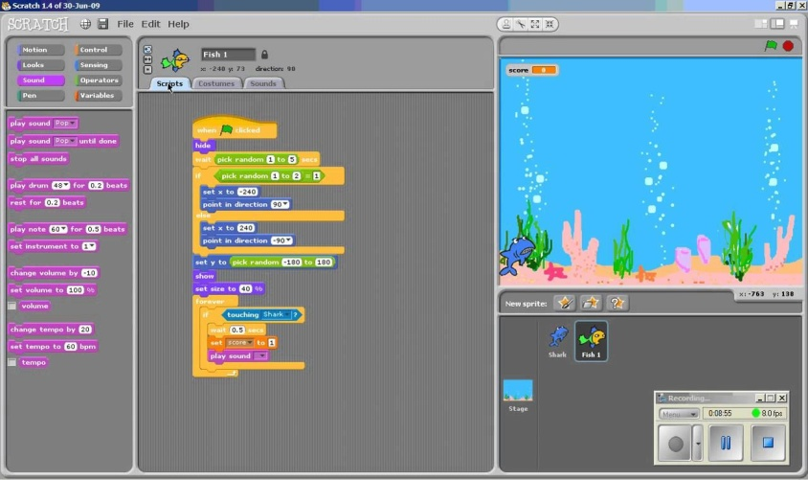**2.3 Related Studies/Systems**

Figure 1: Screenshot of Scratch Programming

https://scratch.mit.edu/projects/980156/

**Scratch Programming**

This game serves as a teaching platform for game programming. It teaches creating various stages for different stages of the game, keeping scores, keeping time, broadcasting, sprite creation, animation and more.

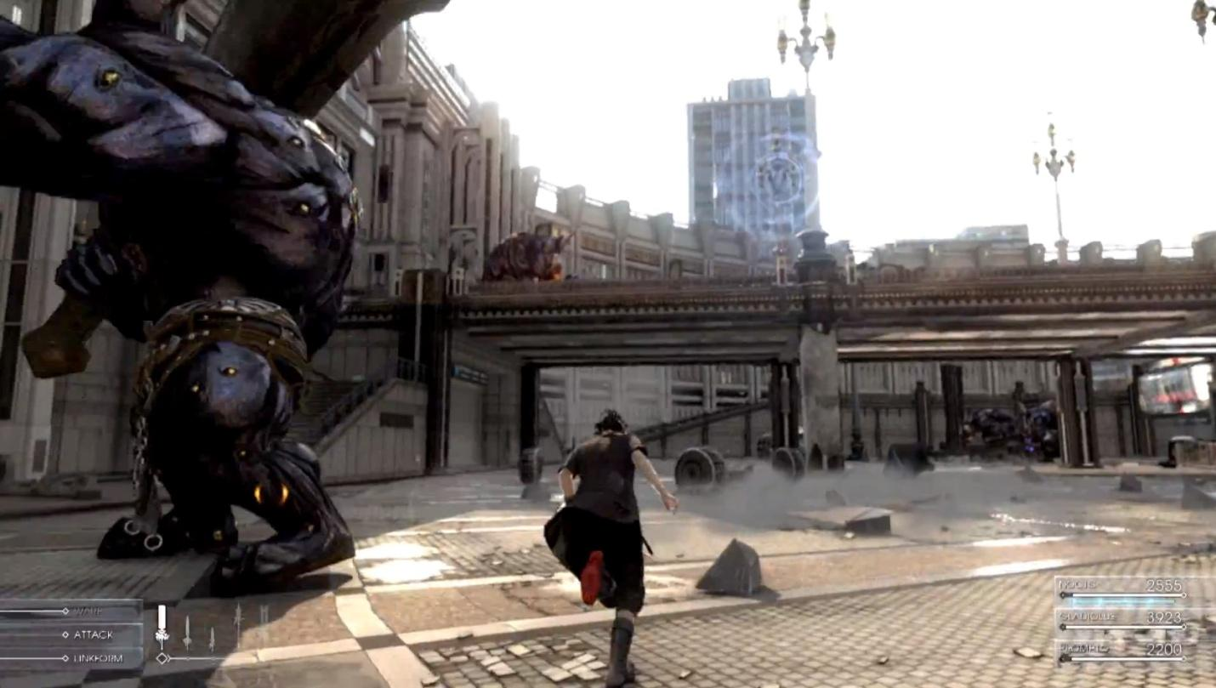As you know a cat comes with 9 lives. Well, the Scratch cat can increase its lives by catching prizes (party hats) and avoiding the bouncy ball. Use the arrow keys to navigate. You have only 60 seconds to finish this game.

Figure 2: Screenshot of Final Fantasy

http://finalfantasy.wikia.com/wiki/Final_Fantasy_series

**Final Fantasy**

The Final Fantasy series usually puts the player in control of multiple characters in a party, though there are exceptions. The player will build the party's strength by gradually acquiring new abilities and equipment to handle more powerful opponents. In many games this task extends beyond the main story with challenging super bosses and bonus dungeons serving as optional tests of skill. As a Japanese role-playing game, many instalments—particularly the earlier instalments in the main series, or the throwback spin-offs returning to old formulas—involve frequent use of menus to select items, skills and upgrades.

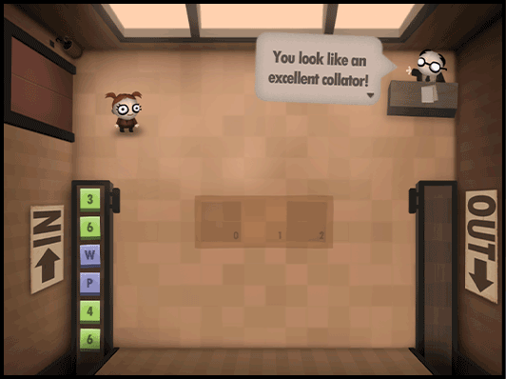

Figure 3: Screenshot of Human Resource Machine

https://tomorrowcorporation.com/humanresourcemachine  
http://store.steampowered.com/app/375820/Human_Resource_Machine/

**Human Resource Machine**

Human Resource Machine is a puzzle game. In each level, your boss gives you a job. Automate it by programming your little office worker! If you succeed, you'll be promoted up to the next level for another year of work in the vast office building. Congratulations!

Don’t worries if you've never programmed before - programming is just a puzzle solving. If you strip away all the 1's and 0's and scary squiggly brackets, programming is actually simple, logical, beautiful, and something that anyone can understand and have fun with!

Your office is a simple computer. You have an inbox and outbox (inputs and outputs), and a few slots on the floor to store stuff for later (memory). Your little office worker can hold exactly one box in his or her hands at a time (like an accumulator). Boxes (data) display letters or numbers.

In each level, your boss gives you a task, like "Take everything from the INBOX, and put it in the OUTBOX!" Automate it by programming your little office worker with simple drag n' drop commands. You start the game with just 2 commands, and gradually earn more as you're promoted. The entire language contains only 11 total commands - but they're enough to simulate almost any computer algorithm in the world!

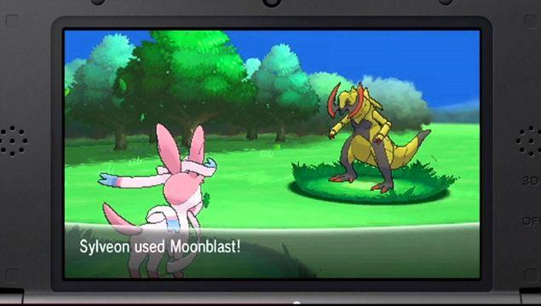

Figure 4: Screenshot of Pokemon Game

https://bulbapedia.bulbagarden.net/wiki/Pok%C3%A9mon_games

**Pokemon Video Game**

The Pokémon games are all video games in the Pokémon franchise. All games in the standard style are considered the base, definitive canon for the Pokémon series. All other parts of Pokémon canon, including but not limited to the Pokémon anime, Pokémon manga, Pokémon Trading Card Game, and the Pokémon Trading Figure Game, are derived from the Pokémon world and concepts set forth in the games. There are currently 122 games known.

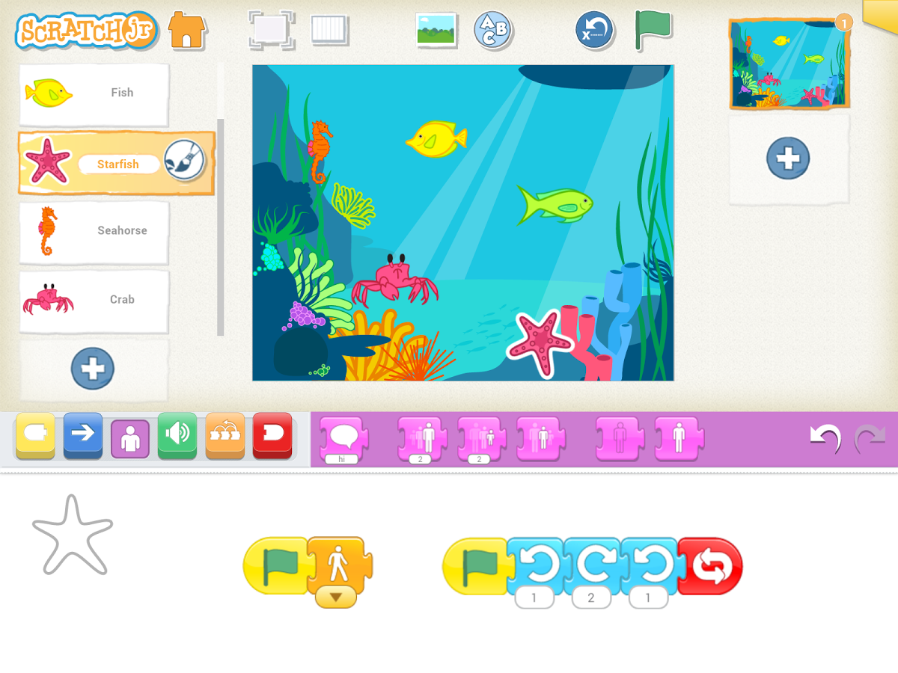The games can be grouped into seven generations. The defining point of where a new generation begins is when a new core series Pokémon game is released with a set of new Pokémon in its Pokédex. Games are also split between core series games and spin-off games. In most core games, the player can choose one out of three Pokémon to start their journey with. Spin-off games give players various options in the way they both obtain and make use of Pokémon.

Figure 5: Screenshot of Scratch Jr

https://www.scratchjr.org/

**Scratch Jr**

Coding is the new literacy! With ScratchJr, young children (ages 5-7) can program their own interactive stories and games. In the process, they learn to solve problems, design projects, and express themselves creatively on the computer.

**Summary of Related Studies and Literature**

Types of Games 3D gaming is interactive computer entertainment that is graphically presented in the three dimensions of height, width and depth; the addition of depth to 2D gaming enabled the exploration of virtual worlds with more realistic representation.

During the Super NES era, Nintendo developed a scant few games that made use of what the company deemed the "Super FX Chip." This special chip allowed for the development of games using rudimentary polygon graphics for games such as Star Fox and Stunt Race FX. The 2.5D animation is 2D animation in a 3D space.

History, the "Platform" refers to the specific combination of electronic components or computer hardware which, in conjunction with software, allows a video game to operate.

Type of platforms: Pc game, console game, arcade game, handheld and many more.

Memory Video games make players visions become more sensitive to slightly different shades of colors.

This is called contrast sensitivity, and observed particularly in first person shooter games players.

Video games help children with disorder reads faster and with better accuracy.

Platforms, A reality that a lot of people play video games also that video games can have a positive or a negative role in the persons that use it.

The imagination of the Filipinos is wide and beautiful, so people are tends playing video games made by Filipinos that's why Philippines is the third largest source of developing a game and animation outsourcing.

With the directive of CMO 02, gamers now had an avenue to study and develop the skills that they would apply to the games they loved to play and the network started to grow.

Game creation, as well as gaming itself, is one of the most boundless and innovative fields that we have come up with in the past century.

The people such as students and events like the Global Game Jam not only give Philippines a better chance of standing with game development giants, but also to leave their mark on the world.

"Ubisoft just opened up shop here and, if they succeed, more companies should follow." Thru population growth the video games is increasing, that's why many companies opened and develop games for the people.

According to Erick V. Garayblas, the one-man force behind Kuyi Mobile, says that he has seen "The local game development industry and community grow tremendously over the past few years." Because of the population the development of video games industry and community grow that's why researchers develop a game that people wants to play and to share to others.

The Philippines has long been associated with outsourcers and service firms rather than dedicated development studios, as Alvin Juban, president and chairman of the local Game Developers Association of the Philippines chapter and director of business development at Synergy88 Digital, recounts.

The entire language contains only 11 total commands - but they're enough to simulate almost any computer algorithm in the world! The Pokémon games are all video games in the Pokémon franchise.

All games in the standard style are considered the base, definitive canon for the Pokémon series.

All other parts of Pokémon canon, including but not limited to the Pokémon anime, Pokémon manga, Pokémon Trading Card Game, and the Pokémon Trading Figure Game, are derived from the Pokémon world and concepts set forth in the games.

The defining point of where a new generation begins is when a new core series Pokémon game is released with a set of new Pokémon in its Pokédex.

In most core games, the player can choose one out of three Pokémon to start their journey with.

Spin-off games give players various options in the way they both obtain and make use of Pokémon.

Coding is the new literacy! With ScratchJr, young children can program their own interactive stories and games.

The idea was to develop an interface that allowed computer programs to be built by simply dragging and dropping puzzle blocks to represent complex programming constructs and commands. This approach lowered the bar for experimenting with programmatic thinking, making it possible for students to create interactive animations and small games without writing a single line of code. This simple concept removed the need to learn the syntax of a formal programming language, and made teaching and learning the basics of computer science accessible to younger learners and to teachers with no formal coding background. Block-based coding is an excellent approach to kick start learners’ excitement and interest in programming.

**2.4 Conceptual Framework**

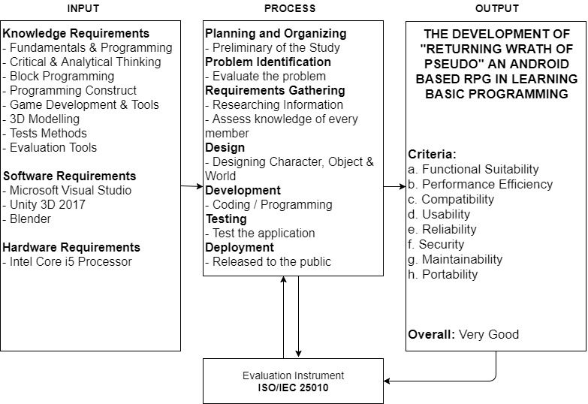

Figure 6: Conceptual Framework

The system approach (Input – Process – Output) was used in describing the conceptual framework of the study. The input consist of particular language, tools, software and hardware used to developed the system and process of analysis of data and maintaining the system to prevent errors. The process describe the life cycle of the system. The output displays the quality of the system.

**2.5 Definition of Terms**

The key terms in the study are given the following operational and technical definitions based on the context of the study.

1. **ReWOP** Returning Wrath of Pseudo
2. **Nexo** The main protagonist of the game and the top 1 player
3. **Pheta** Top 2 player of the game
4. **Pseudo** Top 3 player of the game
5. **Overworld** The 1st world, this is the main capital of the game
6. **Underworld** The undead city
7. **Na’rak** The last world of the game, the hell

**CHAPTER 3**

**METHODOLOGY AND TECHNICAL BACKGROUND**

In this chapter, the development process of the project will be discussed in detail. All methodologies used from research to development will be tackled. These includes the project design and the software development method that will be applied throughout the span of the study.

**3.1 Research Methodology**

The   descriptive method will be used by the researchers for gathering data that will be included in all different stages of software development and finalizing all the requirements. The term descriptive research refers to the type of research question, design, and data analysis that will be applied to a given topic .It can help the researchers complete the requirements. Using this method, it is possible to collect data from large or small populations.

**3.2 Software Development Methodology**

The researchers will be applying the Modified Waterfall with Risk Reduction as the SDLC model

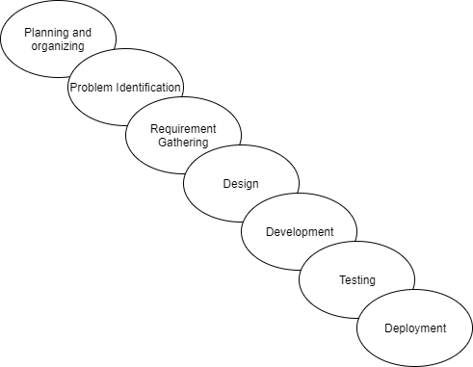

Figure 7: Sashimi Model (Modified Waterfall)

**Phase 1: Planning and Organizing**

Planning and organizing is the preliminary stage on the development of the project. In this stage, the proponents will assess their skill whether they are able to create and materialize the project. Next is gathering of ideas. This will delve on the proposals feasibility. Finally, the proponents will create the final title and define the project’s general concept.

**Phase 2: Problem Identification**

In this stage, the main problem will be identified so that the project will have a clear purpose and have an adequate solution. This phase includes the assessment of the current state of the problem. In this stage, the proponents will evaluate the severity of the problem to identify what should be focused on. Next is researching other systems. The researchers will dig through other related systems and literature and will use them as guides and benchmark in creating the project. After identifying and gathering necessary information, the proponents will formulate a solution and will be applied with the system. After the solution is formulated, the project will be conceptualized. In the studies case, the project has been conceptualized in a form of a game.

**Phase 3: Requirement Gathering**

This phase will be the researching and acquiring all necessary information that will materialize the project. In this phase, the proponents will assess the knowledge of every member in regards to the development of the project. This phase will also include the definition of the project’s scope and limitations. The team will also assess the needed development tools in this phase. After this, the developers will be assigned to what specific job they will be in creating and developing the game. Finally, the proponents will define the target software and hardware.

**Phase 4: Design**

In the design phase the developers will define the specifics of the project which includes the gameplay, main premise of the game, the characters, the art style, the type of the game, and the genre. The developers will also create a storyline in which the game will go through.

**Phase 5: Development**

In this phase, the development of the game will commence. This will be the most tedious part of the whole process in creating the game. Most of the time will be used in this stage as this is very crucial to the outcome of the game.

The developers will start by creating the design for the game characters, this will be the creation and animation of the characters. Next is the world design. The worlds design will be created and tested in this stage. After this the developers will create the Interface design of the game which includes the home menu, the pause menu, and the block programming interface. After all designs are finished and furnished the proponents will create a five-to-ten-minute prototype of the game and will be presented to the beneficiary. After, some feedback, the game will be furnished more and will be going through the process of scripting, coding, and debugging. Some of the games cut-scenes will be created and will be inserted in the main parts of the plots key points. Lastly, the game will be assembled to one whole build and will create the executable for the preliminary stages of testing.

**Phase 6: Testing**

This phase includes the testing of the game. This will start with the developers’ rigid test on the game and will furnish some unseen bugs during the development. This will also include the testing of the game in other devices. After this it will be tested by the potential users of the game and will be assessing the acceptability of the game. Errors seen by the testers will also be debugged. Finally, the game will go through the process of evaluation. The evaluation will be done using an instrument which will later be discussed in this chapter. This will be a standardized method of evaluation and will be conducted through a survey.

**Phase 7: Deployment**

This phase is the final part of the life-cycle of this game in which the game will be released to the public, this includes the uploaded game and possibly the assessment of the games’ outcome and finally the support on the game users.

**3.3 Evaluation Procedure**

In the process of evaluation, the proponents will be using the **ISO/IEC 25010**as evaluation tool. The ISO 25010 has been a standardized evaluation for the acceptability of software.

The quality model is the cornerstone of a product quality evaluation system. The quality model determines which quality characteristics will be taken into account when evaluating the properties of a software product.

The quality of a system is the degree to which the system satisfies the stated and implied needs of its various stakeholders, and thus provides value.

**3.4 Respondents**

The study will be requiring respondents that includes teens that are interested in taking a computer related course. Also, senior high school students taking up the ICT strand. This will be the basis of the feedback from the user as this group of respondents are the main target of the study. The study will be needing at least but not limited to 50 respondents that will cover up the feedback of the user.

In the case of the acceptability of the technical side, the study will also include respondents that are experts in developing games, or literate in computer and software developers. Mainly, these are graduates of computer related course and are very much experts in the field of software development or game development. The study will include at least but not limited to 10 IT experts.

**3.5 Statistical Treatment of Data**

**Likert Scale**

After the questionnaire is completed, each item may be analysed separately or in some cases item responses may be summed to create a score for a group of items.

Table 1: The Five-Point Likert Scale

|  |  |
| --- | --- |
| **Scale** | **Interpretation** |
| 5 | Excellent |
| 4 | Very Good |
| 3 | Good |
| 2 | Fair |
| 1 | Poor |

Table 2: Range Evaluation Rating

|  |  |
| --- | --- |
| **Evaluation Range** | **Interpretation** |
| 4.21 to 5.00 | Excellent |
| 3.41 to 4.20 | Very Good |
| 2.61 to 3.40 | Good |
| 1.81 to 2.60 | Fair |
| 1.00 to 1.80 | Poor |

Weighted mean was used to measure the general response of the survey samples, whether they agree to a given statement or not.

**3.6 Testing Procedures**

The project will undergo the Alpha and Beta testing after being completed and built. In the Alpha testing phase the project will be tested by the developers and will evaluate the results given by the game. After addressing and resolving errors. The developers will prepare the project for the Beta testing. The beta test will be conducted to potential users and will be given evaluation after the testing has been conducted. After beta testing the project will undergo some code cleaning before the build for the deployment version will be created.

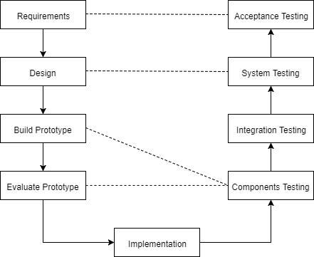

Figure 8: Testing Plan

This diagram will shows the cycle of the testing plan of the alpha beta.

**3.7 Technical Design**

**3.7.1 Software Requirements**

Table 3: Software Requirements

|  |
| --- |
| **Software Requirements** |
| Android SDK |
| Java Development Kit (JDK) |
| Unity 3D 2017 |
| Photoshop CC 2015 |
| Blender |

This section list the application needed to develop an Android 3D Game.

**3.7.2 Hardware Requirements**

Table 4: Hardware Requirements

|  |  |
| --- | --- |
| **Recommended Requirements** | **Minimum Requirements** |
| Android 4.0 + or Later | Android 4.1 or Later |
| 2 GB and up RAM | 2 GB RAM |
| 4-Core CPU | Quad Core |

This section list the minimum and recommend requirements needed to properly execute the system

Table 5: Development/Implementation

|  |  |
| --- | --- |
| **Development** | **Implementation** |
| Android SDK | Android: OS 4.1 Later; Quad Core 1.4 GHz Cortex-A53 |
| Java Development Kit (JDK) |  |
| Unity 3D |  |
| Photoshop CC 2015 |  |
| Blender |  |

This section list the requirements for development and for implementation of the system

**3.7.3 UML Design**

The proponents chose to use the Unified Modelling Language as a Designing tool for modelling the project. UML is a standardized modelling language that will be a representation of the project’s design.

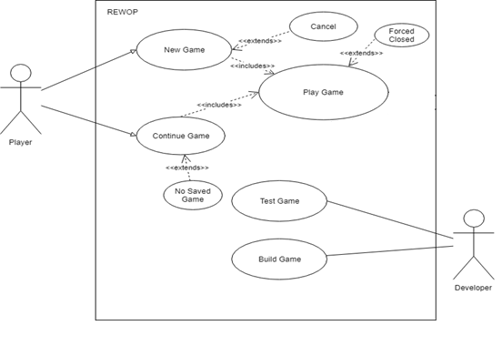

Figure 9: Use Case Diagram

In this diagram which visualize the interaction of the player to the game.

Name: New Game

Participating actor: Player

Entry Condition:

* Player is at the Main Menu
* Player is ready to play the game

Exit Condition:

* Player enters the new game

Event Flow:

1. Player selects the New Game button
2. Game displays dialog box confirming to overwrite the saved data if there are any saved game
3. Player selects ‘Yes’ on the dialog box
4. Game loads
5. Player plays the new game

Exceptional Case:

* Player cancels to make a new game

Name: Continue Game

Participation actor: Player

Entry condition:

* Player is at the main menu
* There is an available save data
* Player is ready to play the game

Exit Condition:

* Player enters the loaded game

Event Flow:

1. Player selects the Load Game button
2. Game loads the saved data
3. Player plays the game

Exceptional case:

* There are no available saved data

Name: Test Game

Participating actor: Developer

Entry Condition:

* Developer test and debug the game

Exit Condition:

* The game has been debugged

Event Flow:

1. Developer run and tested on Unity 3D
2. The game debugged by developer

Name: Build Game

Participating actor: Developer

Entry Condition:

* The game has no bug and ready for compilation

Exit Condition:

* The game has been compiled

Event Flow:

1. The developer has setup the compiler
2. The developer selects compile
3. The executable file is already compiled

Exceptional Condition:

* The compiler has found a bug

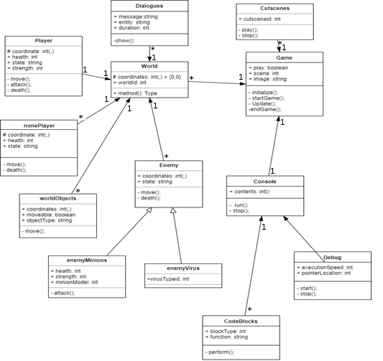

Figure 10: Class Diagram

In this section shows the attributes and the methods of the game.

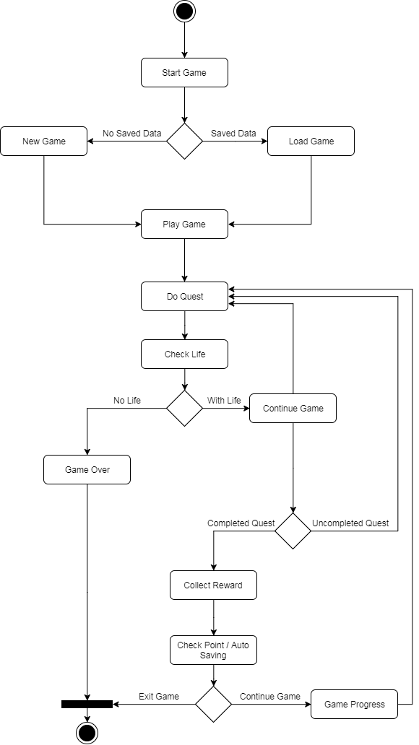

Figure 11: Activity Diagram

In this diagram its show the activity diagram which are related to program flow plans, are used to illustrate activities.

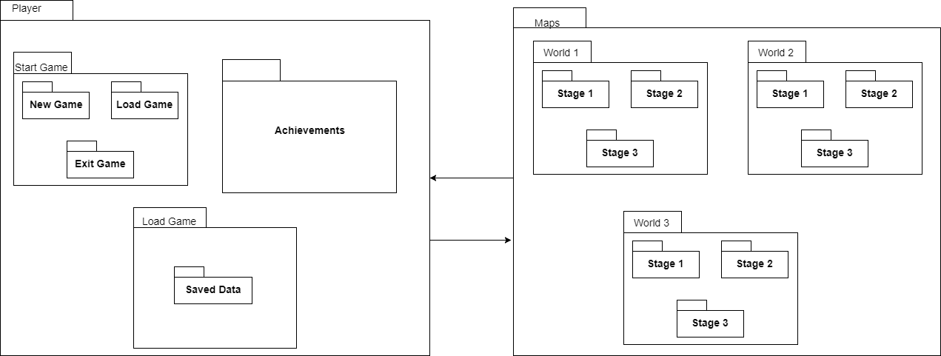

Figure 12: Package Diagram

In this diagram, its shows packages and dependencies between the packages used to demonstrate the views of the system.

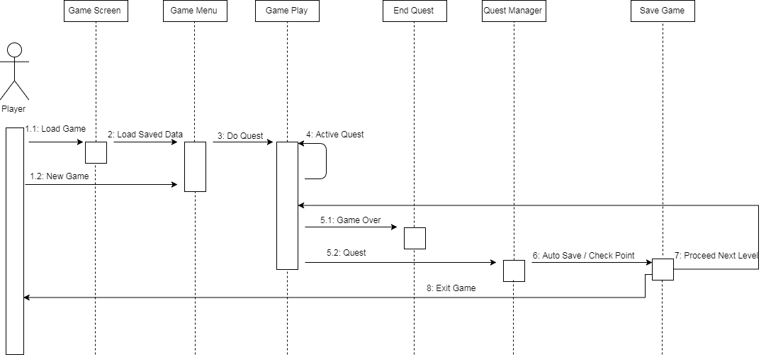

Figure 13: Sequence Diagram

In this section shows the process of the gameplay.

**Semantics**

**Main ()** - the base block in which the compiler will sequencially read

Statements:

**Quick Attack** - a melee attack against an opponent

**Block** - to guard against melee attacks of the opponent

**Spell** - a long range attack that can damage blocking opponents

**IF-Else** - a statement that takes a condition and executes true if the condition returns true and false if the condition returns false.

**Repeat** - a statement that takes a whole number and will repeat the execution of its contents and decrements the chosen number while that number does not equal to 0.

**Compiler Process**

**…….**

**3.8 Implementation/ Deployment Plan**

The next phase is implementation where the changes takes place which the threats identified have been fixed. Prior to this change, few activities are needed to be considered, otherwise the implementation will fail. Activities such as testing, training and evaluation are looked into before the new replaced. Another activity that is carried out is the post implementation activities to review the game to ensure the produce of the expected results and meet the required quality.

Deployment plan involves defining the sequence of operations or steps that must be carried to deliver changes into a target system environment. The individual operations can be executed manually. Deployment plans are usually well defined and approved prior to the deployment date. Deployment plans may rehearse to ensure there are no issues during actual deployment.

1. Free File Hosting (Media File) - Is an Internet hosting service specifically designed to host user files. It allows users to upload files that could then be accessed over the internet only used by the user of the phone after a password or other authentication is provided.
2. File Sharing - Is the practice of distributing or providing access like Share It, Bluetooth and File Transfer. File sharing may be achieved in a number of ways. In file sharing you can share such as multimedia (audio, images and video), documents and games.

**Chapter 4**

**RESULT AND DISCUSSIONS**

In this chapter, shows the result and discussed the detailed project description, project structure and the user interface of the project. It also provides the project capabilities and the limitations of the project. The last part shows the result of the project evaluation that we conduct to the respondents.

**4.1 Project Description**

ReWOP (Returning Wrath of Pseudo) a learning RPG game was created in C# scripting, Unity game engine, Blender for 3D modelling and Photoshop for other designs. This project is developed with an objective that this can be used as a tool in teaching future IT students to be introduced and be familiarized in the field of basic programming. The project will be installed or deployed in an Android operating system with a minimum version of 4.1 Jelly Bean. The project had been developed with a good graphic user interface to provide ease while they are playing. We patterned the user interface graphics for the mobile build. The project can help users to have knowledge and be familiarized in block programming and logic formulation.

The Returning Wrath of Pseudo is a puzzle & role playing game with 3D third-person view game. It consist save points every world that the player accomplished and there are achievements. The feature of the game is the block programming to fight the boss in every world after you defeat the boss you’ll advance to the next stage or world.

**4.2 Project Structure**

**Algorithm Used in ReWOP Program**

*Codes for compiling*

**4.3 Screen Hierarchy of the Program**

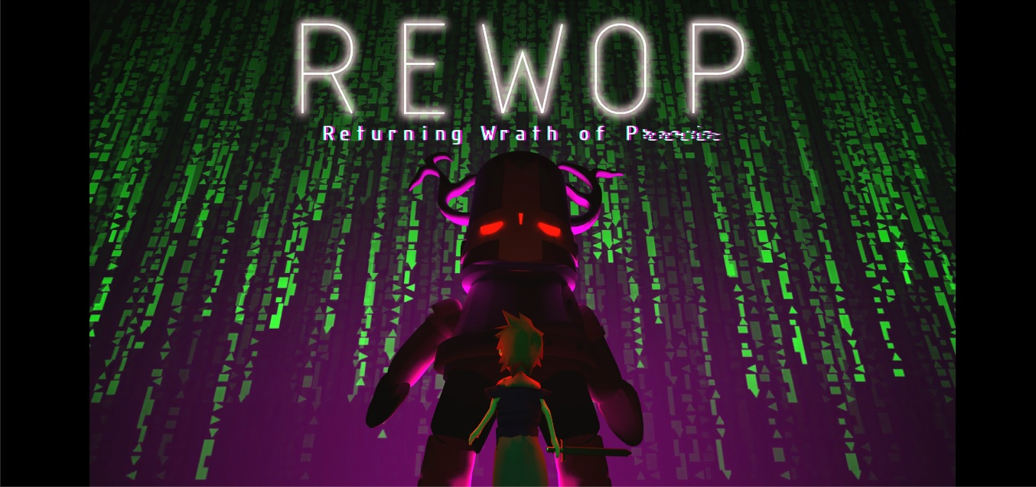

Figure 14: Splash screen

Figure 14 shows the name of the game.

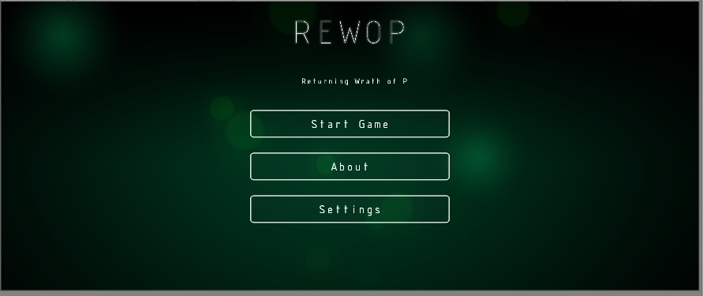

Figure 15: Main menu

Figure 15 shows the main menu of the game where you can see the start game, about, and settings.

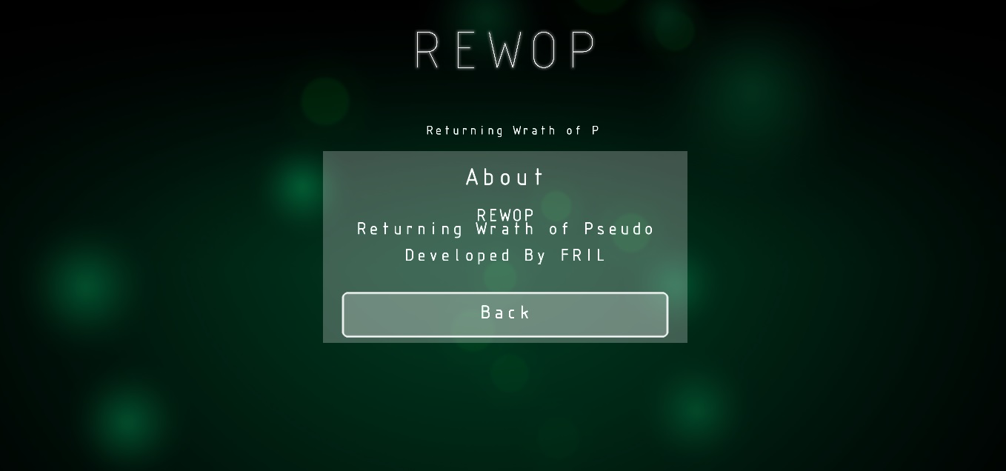

Figure 16: About

Figure 16 shows the title and the developers.

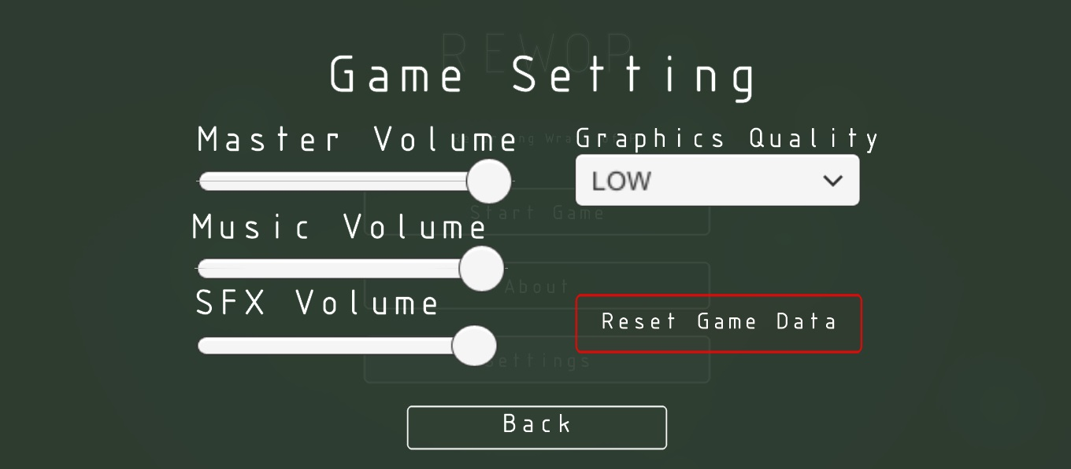

Figure 17: Settings

Figure 17 shows the game setting where you can change the master volume, music volume, sfx volume and graphics quality. You can reset the game through settings.



Figure 18: Loading

Figure 18 shows the load bar.

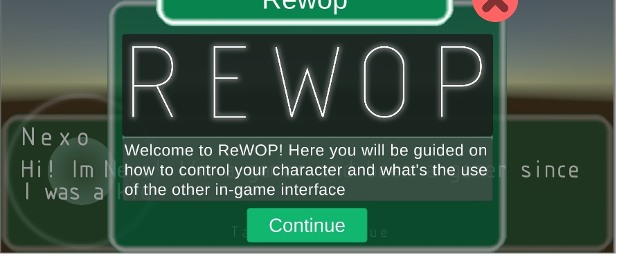

Figure 19: Welcome dialogue

Figure 19 shows the first dialogue of the game.

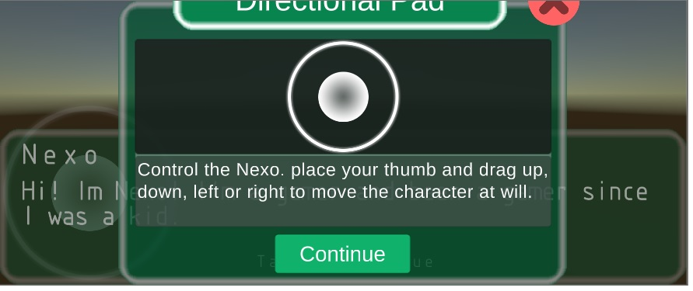

Figure 20: Directional pad

Figure 20 shows the directional pad for the movements of the character.

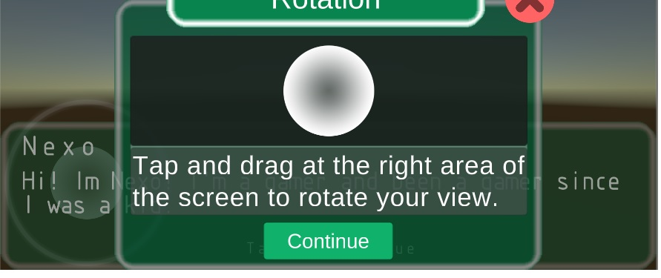

Figure 21: Rotation

Figure 21 shows the camera control for the view of the player.

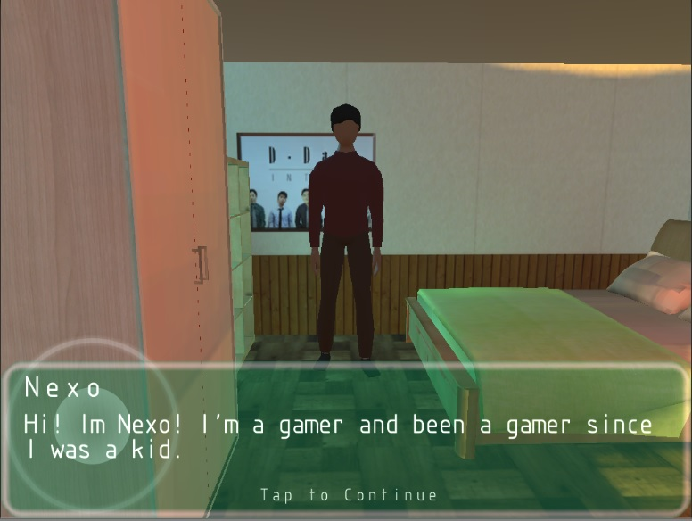

Figure 22: Nexo

Figure 22 shows the main character of the game Nexo.

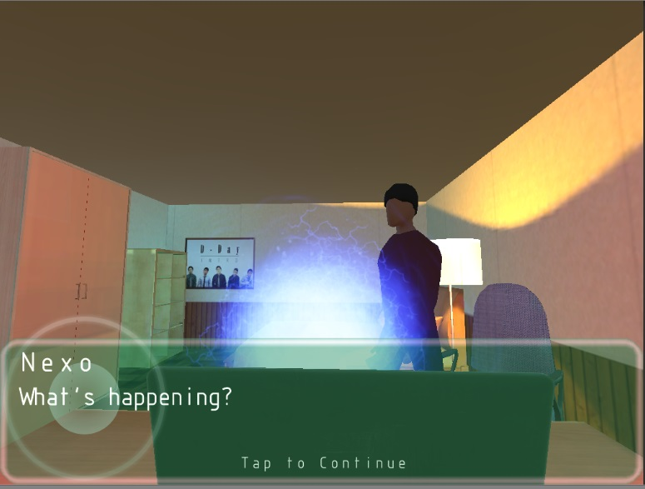

Figure 23: Nexo captured by the game

Figure 23 shows Nexo captured by the game and trapped.

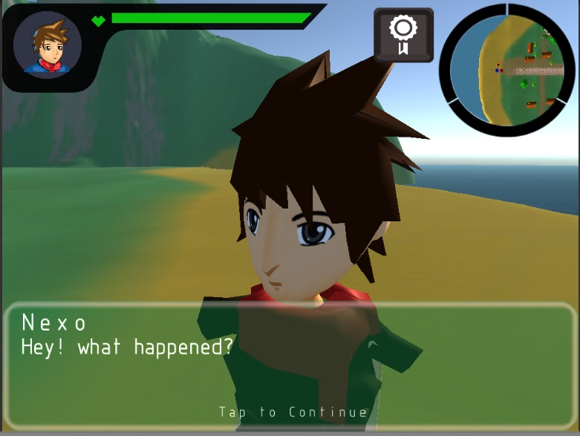

Figure 24: Nexo inside the game

Figure 24 shows Nexo inside the game.

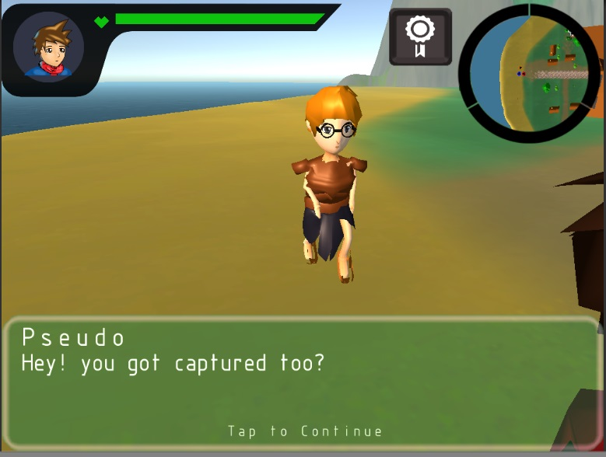

Figure 25: Pseudo

Figure 25 shows pseudo the friend of Nexo and the top two player.

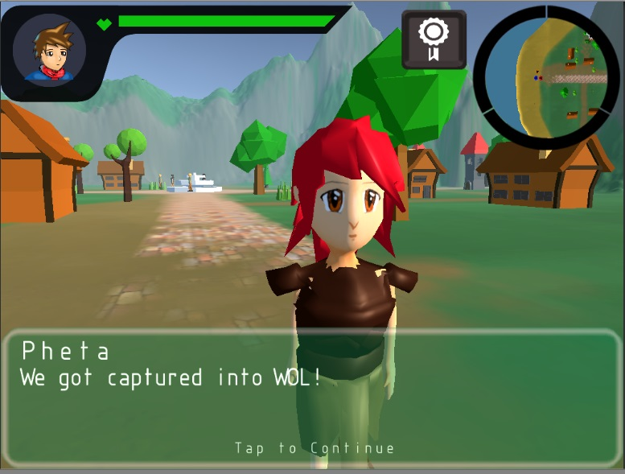

Figure 26: Pheta

Figure 26 shows Pheta the other friend of Nexo and the top 3 player.

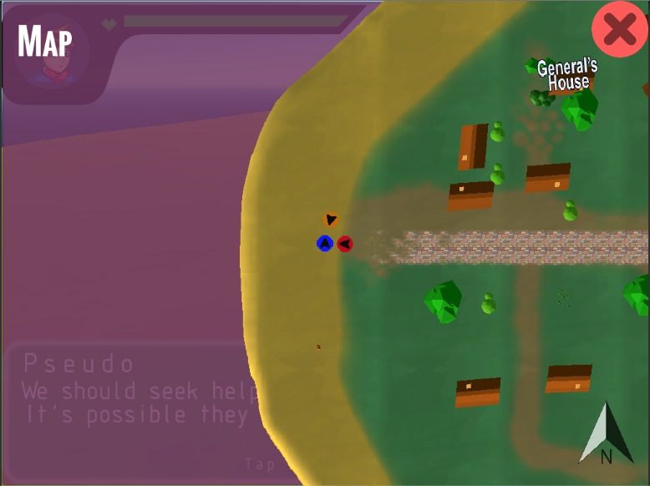

Figure 27: Map

Figure 27 shows the places where the player’s quest is.

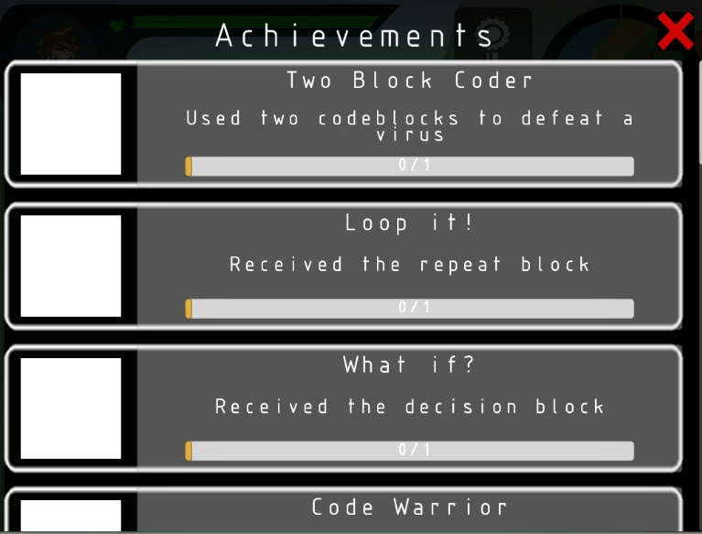

Figure 28: Achievments

Figure 28 shows what the palyer achieve while playing.

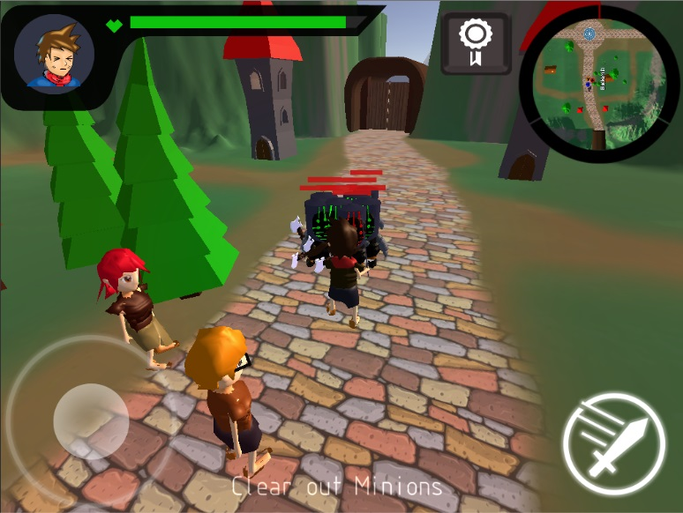

Figure 29: Nexo fights against the viruses

Figure 29 shows Nexo fighting the viruses to save the villagers.

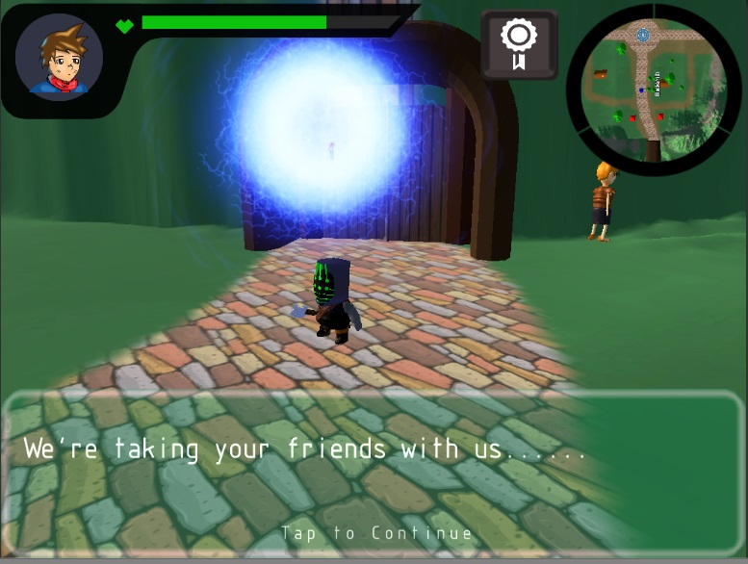

Figure 30: Nexo’s friends abducted by virus

Figure 30 shows that the friends of Nexo had been abduct by the virus.

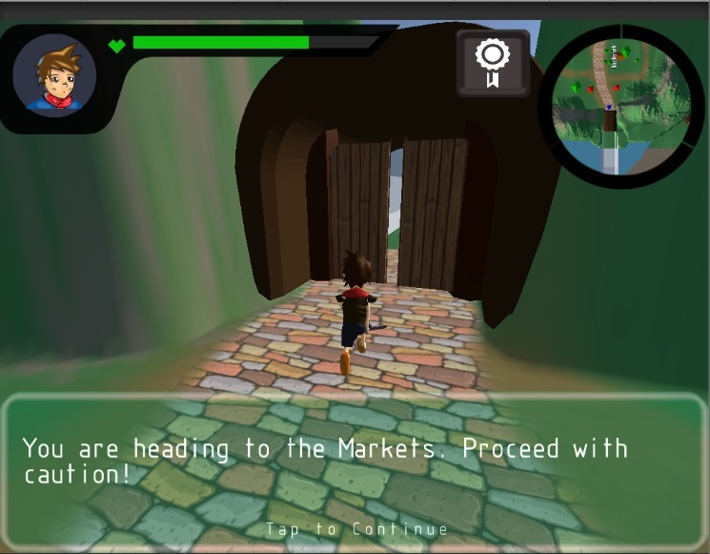

Figure 31: Gate to market

Figure 31 shows that Nexo is travelling through the gate going to market.

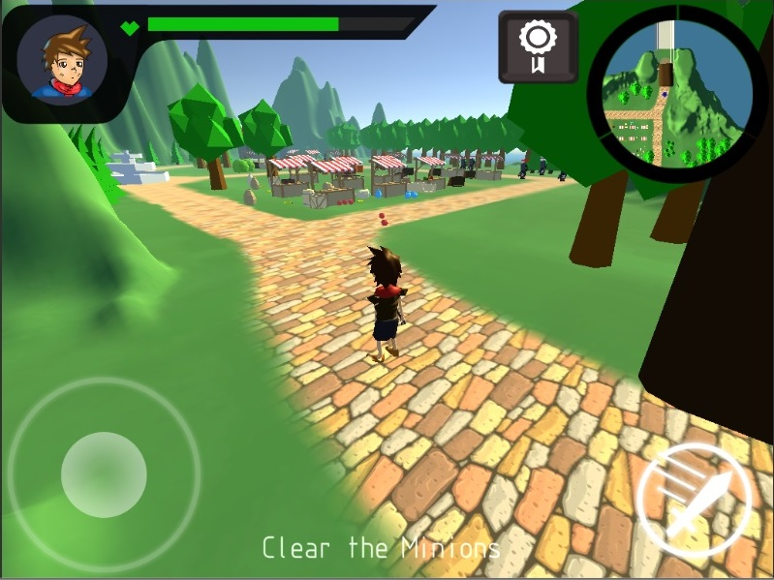

Figure 32: The Market

Figure 32 shows the market place where viruses invaded.

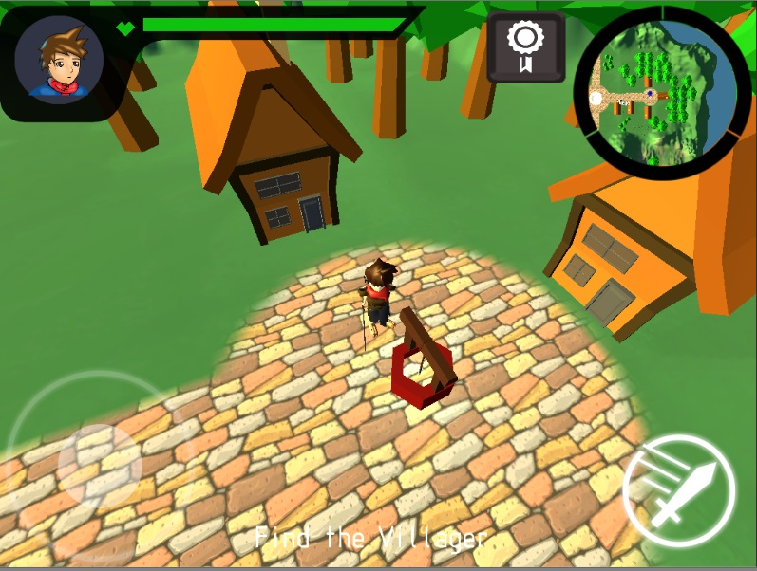

Figure 33: The Well

Figure 33 shows the well where you can regen the life of Nexo.

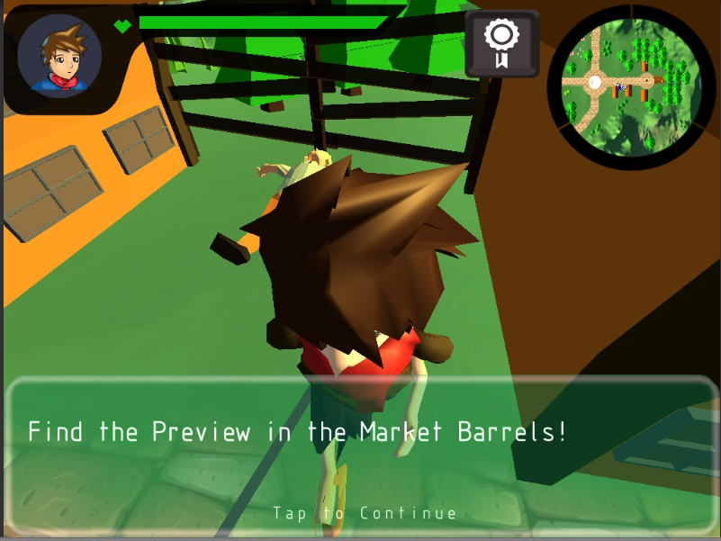

Figure 34: Finding the preview

Figure 34 show that Nexo must find the view so he can fight the boss.

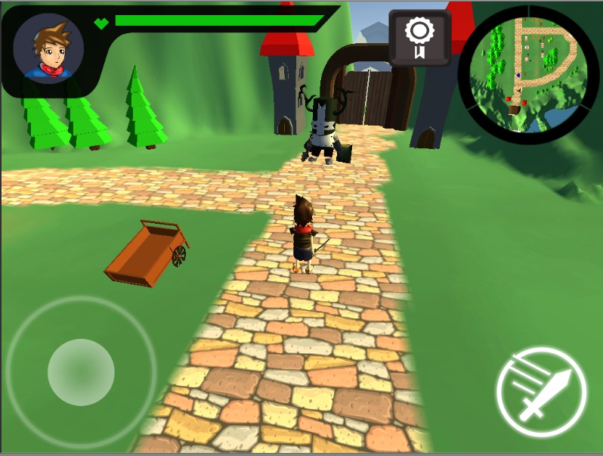

Figure 35: Nexo approaching the boss

Figure 35 shows that Nexo approach the boss to fight and to pass and go to the next stage.

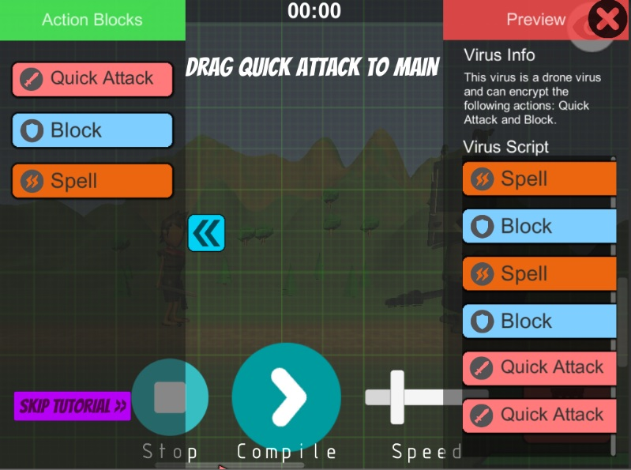

Figure 36: Code blocks

Figure 36 shows how the player fight the boss using code blocks.

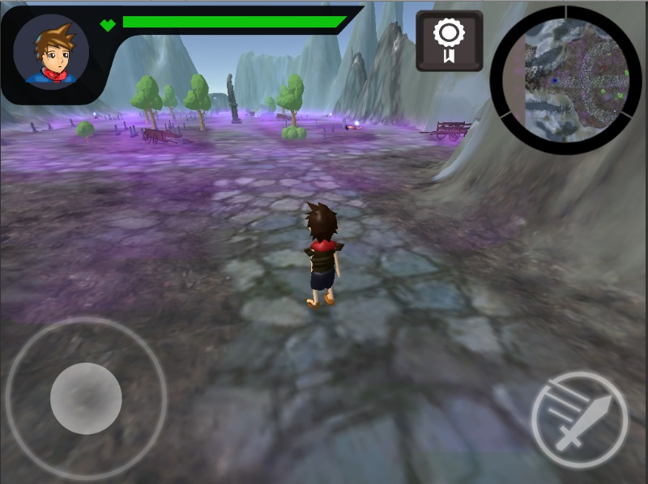

Figure 37: Underworld (Stage 2)

Figure 37 shows that Nexo arrived in Underworld.

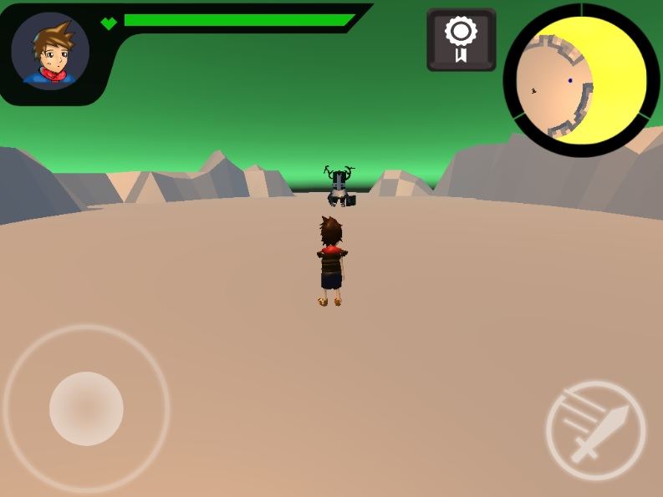

Figure 38: Narak (Stage 3)

Figure 38 shows that Nexo is in the last world and to fight the boss so he can go back to the real world.

**4.4 Project Capabilities and Limitations**

Capabilities

* This project is a user friendly.
* It can be installed in an Android operating system with a minimum version of 4.1.
* The project has 3 worlds and every world has 3 stages and each stage has 5 quests to accomplish and there are achievements.
* Each boss battle has a block programming scene and in the first boss the tutorial will appear to teach the user how to play with it.

Limitations

* Offline game
* Single user only
* Only one character will be used.
* No character inventory for items.

**4.5 Project Evaluation**

Respondents of the study include 50 users of the software and 10 information technology experts. Respondents from different courses such as business administration, HRM, tourism, criminology, and psychology and information technology were selected. Information technology experts include programmers, systems analysts, and instructors in the field of information technology. ISO 25010 questionnaires for software quality were used by the respondents to assess the acceptability of the program.

Table 6: Numerical Scale

|  |  |
| --- | --- |
| **Scale** | **Interpretation** |
| 4.21 to 5.00 | Excellent |
| 3.41 to 4.20 | Very Good |
| 2.61 to 3.40 | Good |
| 1.81 to 2.60 | Fair |
| 1.00 to 1.80 | Poor |

The table above shows the numerical scale used in the software evaluation and its equivalent interpretation.

Table 7: Users’/experts’ evaluation based on functionality

|  |  |  |
| --- | --- | --- |
| **Functionality sub-characteristics** | **Weighted**  **Mean** | **Interpretation** |
| Functions required for the system are implemented (**suitability)** | **4.50** | Excellent |
| Functional accuracy is provided (**accurateness**) | **4.48** | Excellent |
| Functions meet specifications (**compliance**) | **4.37** | Excellent |
| Ease of connecting with other systems is provided (**interoperability**) | **4.45** | Excellent |
| Substantial security is provided (**security**) | **4.50** | Excellent |
| **Mean** | **4.48** | Excellent |

The general weighted mean for functionality is 4.45. Suitability has the highest mean equivalent to 4.50 and compliance has the lowest mean equivalent to 4.37.

Table 8: Users’/experts’ evaluation based on reliability

|  |  |  |
| --- | --- | --- |
| **Reliability sub-characteristics** | **Weighted**  **Mean** | **Interpretation** |
| The ability to respond to the [environment](https://en.wikipedia.org/wiki/Social_environment) in an [appropriate](https://en.wikipedia.org/wiki/Norm_(sociology)) manner **(Maturity**) | **4.63** | Excellent |
| The proportion of time a system is in a functioning condition (**Availability**) | **4.57** | Excellent |
| The property that enables a [system](https://en.wikipedia.org/wiki/System) to continue operating properly in the event of the failure (**Fault Tolerance**) | **4.40** | Excellent |
| Refers to the ability to restore your deployment to the point at which a failure occurred (**Recoverability**) | **4.52** | Excellent |
| MEAN | **4.53** | Excellent |

The general weighted mean for reliability is 4.43. Maturity has the highest mean equivalent to 4.50 and fault tolerance has the lowest mean equivalent to 4.40.

Table 9: Users’/experts’ evaluation based on usability

|  |  |  |
| --- | --- | --- |
| **Usability sub-characteristics** | **Weighted**  **Mean** | **Interpretation** |
| To identify from knowledge of appearance or characteristics(**Recognizability**) | **4.48** | Excellent |
| Measure of the degree to which a user interface can be learned quickly and effectively(**Learnability**) | **4.58** | Excellent |
| The ability to keep an equipment(**Operability**) | **4.57** | Excellent |
| **Error Protection** | **4.33** | Excellent |
| **UI Aesthetics** | **4.57** | Excellent |
| **Accessibility** | **4.60** | Excellent |
| MEAN | **4.52** | Excellent |

The general weighted mean for reliability is 4.52. Accessibility has the highest mean equivalent to 4.60 and error protection has the lowest mean equivalent to 4.33.

C: Experts’ evaluation based on performance efficiency

|  |  |  |
| --- | --- | --- |
| **Performance Efficiency sub-characteristics** | **Weighted**  **Mean** | **Interpretation** |
| **Time Behavior** | **4.20** | Very Good |
| **Resource Utilization** | **4.60** | Excellent |
| **Capacity** | **4.30** | Excellent |
| MEAN | **4.37** | Excellent |

The general weighted mean for reliability is 4.37. Resource utilization has the highest mean equivalent to 4.60 and time behaviour has the lowest mean equivalent to 4.20.

Table 11: Experts’ evaluation based on compatibility

|  |  |  |
| --- | --- | --- |
| **Compatibility sub-characteristics** | **Weighted**  **Mean** | **Interpretation** |
| **Co-existence** | **4.60** | Excellent |
| **Interoperability** | **4.30** | Excellent |
| MEAN | **4.45** | Excellent |

The general weighted mean for reliability is 4.45. Co-existence has the highest mean equivalent to 4.60 and interoperability has the lowest mean equivalent to 4.30.

Table 12: Experts’ evaluation based on security

|  |  |  |
| --- | --- | --- |
| **Security sub-characteristics** | **Weighted**  **Mean** | **Interpretation** |
| **Confidentiality** | **4.30** | Excellent |
| **Integrity** | **4.30** | Excellent |
| **Non-repudiation** | **4.30** | Excellent |
| **Accountability** | **4.10** | Very Good |
| **Authenticity** | **4.30** | Excellent |
| MEAN | **4.26** | Excellent |

The general weighted mean for reliability is 4.26. Confidentiality, integrity, non-repudiation, authenticity has the highest mean equivalent to 4.60 and accountability has the lowest mean equivalent to 4.10.

Table 13: Experts’ evaluation based on maintainability

|  |  |  |
| --- | --- | --- |
| **Maintainability sub-characteristics** | **Weighted**  **Mean** | **Interpretation** |
| **Modularity** | **4.60** | Excellent |
| **Reusability** | **4.40** | Excellent |
| **Analyzability** | **4.30** | Excellent |
| **Modifiability** | **4.40** | Excellent |
| **Testability** | **4.60** | Excellent |
| MEAN | **4.46** | Excellent |

The general weighted mean for reliability is 4.46. Modularity and testability has the highest mean equivalent to 4.60 and reusability and modifiability is the second to the highest mean equivalent to 4.40 and analysability has the lowest mean equivalent to 4.30.

Table 14: Experts’ evaluation based on portability

|  |  |  |
| --- | --- | --- |
| **Portability sub-characteristics** | **Weighted**  **Mean** | **Interpretation** |
| **Adaptability** | **4.50** | Excellent |
| **Install ability** | **4.60** | Excellent |
| **Replace ability** | **4.50** | Excellent |
| MEAN | **4.53** | Excellent |

The general weighted mean for reliability is 4.53. Install ability has the highest mean equivalent to 4.60 and adaptability and replacebility has the lowest mean equivalent to 4.50.

Table 15: Overall Evaluation of the Program

|  |  |  |
| --- | --- | --- |
| **Software Evaluation Characteristics** | **Mean** | **Interpretation** |
| **Functionality** | 4.45 | Excellent |
| **Reliability** | 4.53 | Excellent |
| **Usability** | 4.52 | Excellent |
| **Performance Efficiency** | 4.37 | Excellent |
| **Compatibility** | 4.45 | Excellent |
| **Security** | 4.26 | Excellent |
| **Maintainability** | 4.46 | Excellent |
| **Portability** | 4.53 | Excellent |
| Overall Mean | 4.47 | Excellent |

Overall, the program is perceived to be excellent. It implies that the program is highly accepted by the respondents. Reliability and portability has the highest mean equivalent to 4.53. Security has the lowest mean equivalent to 4.26.

**CHAPTER 5**

**SUMMARY OF FINDINGS, CONCLUSIONS AND RECOMMENDATIONS**

This chapter starts with the summary of findings. The second section presents the conclusions of the study. The last section discusses the recommendations which may lead to the improvement of the program and recommendations for future works.

* 1. **Summary of Findings**

This section summarizes the main research findings of the study. (50) fifty third year information students and ICT students of Lyceum of Alabang and (10) ten instructors of Information Technology conducted an evaluation on our application. The overall mean of the evaluation got 4.47 rating. That equivalent to excellent.

**5.2 Conclusions**

* According to the opinions of the respondents and the findings of the research, our game is effective as most of the objectives have been met.
  1. **Recommendations**

This section will be discussing main aspects to further develop and improve the overall maturity of the game.

The following recomendations are suggested by the researchers:

1. Adding more functions in the block programming

2. Allowing multiple saving slots for player's progress

3. Allowing player to replay encountered boss battles to gain a higher score

4. Expanding worlds to have more quest and more level difficulty of the game